Timofei Komarov

Student number – 000332930

Username - x101763

15.12.2021

Repository - <https://github.com/TimofeiKomarov/Final_Project.git>

MBD solver - final assignment

Assignment

1. To perform the kinematic analysis on acceleration level I solve the equation:

$C_{q}^{d}∙\ddot{q}=g$,

where $g= -{(Φ_{q}∙\dot{q})}_{q}∙\dot{q}$ is the right side of the kinematic acceleration equations, or LHS.

The results are presented on the figure 1.

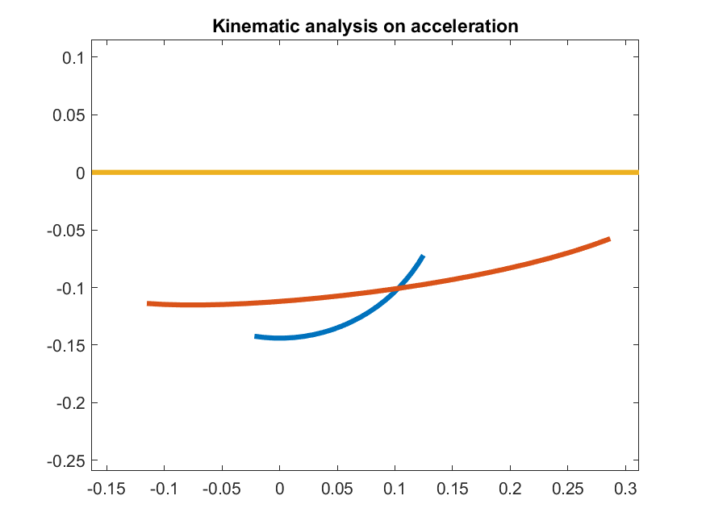

Figure 1 – Kinematic analysis on acceleration

The results seem valid because the crank acceleration vector is directed to the center of movement as it is supposed to be during circular motion at constant velocity. Also, slider acceleration is directed linear, along the axis of its motion.

1. Kinematic analysis with a model of a translational joint is performed using the two constrain equations:

$Φ^{(t, 2)}=\left[\begin{matrix}\left(x_{i}^{P}-x_{i}^{Q}\right)∙\left(y_{j}^{P}-y_{i}^{p}\right)-\left(y_{i}^{P}-y_{i}^{Q}\right)∙\left(x_{j}^{P}-x_{i}^{p}\right) \\ φ_{i}-φ_{j}\end{matrix}\right]=\left[\begin{matrix}0 \\ 0\end{matrix}\right]$;

Also, equations of elements of the Jacobian Matrix and LHS of acceleration equation are used. As result, we receive the same diagrams of kinematic analysis as previous.

1. Solving equations of motion using ode45 solver was implemented according to the equation:

$y'=f(y, t)$;

In this case, I implemented the equations:

$\left\{\begin{aligned}\dot{q}=-C_{q}^{d}(q)\backslash C_{t}^{d}(t) \\ \ddot{q}=C_{q}^{d}(q)\backslash g\end{aligned}\right.$;

As result, we can observe the same diagrams as before.